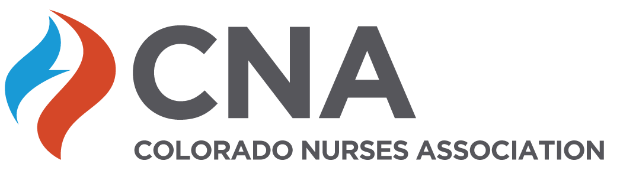
Colorado Nurses Association Approved Provider Activity Documentation Form

Adapted from and used with permission of Pam Dickerson, PhD, RN-BC, FAAN Montana Nurses Association

Based on 2015 ANCC Primary Accreditation Criteria – form effective June 2022

See Instructions on CNA web site for specific guidance in completing the requested information on this form. Call the CNA office at 720-457-1194 for any assistance needed.
Title of Activity: Click here to enter text.
Number of Contact Hours: Click here to enter text.
Activity Type:
- Provider-directed, provider-paced: Live (in person ☐ or webinar ☐)
  - Date of activity:
  - Location of Activity if in-person event:
  - Rationale for number of contact hours to be awarded:
∗ If less than 2 hours:
    - Start time
    - End time
∗ If 2 hours or longer, attach a copy of the full agenda

- Provider-directed, learner-paced: Enduring material
  - Start date of enduring material:
  - Expiration/end date of enduring material:
  - Rationale for number of contact hours to be awarded:
- Learner – directed, learner paced: may be live, enduring material or blended
  - Start date of enduring material:
  - Expiration/end date of enduring material:
  - Rationale for number of contact hours to be awarded:

- Blended activity
  - Describe pre or post activity material:
  - Date of live portion of activity:
  - Location of live portion of activity:
  - Rationale for number of contact hours to be awarded:

Nurse Planner contact information for this activity. Name and credentials: Click here to enter text. Email Address: Click here to enter text.

The Nurse Planner must be a currently licensed registered nurse with a baccalaureate degree or higher in nursing, and be actively involved in planning, implementing and evaluating this continuing

Qualified Planners and Faculty/Presenters/Authors/Content Reviewers

Complete the table below for each person involved with the activity and include name, credentials, educational degree(s). Planning committees must have a minimum of a Nurse Planner and one other planner to plan each educational activity. The Nurse Planner is knowledgeable of the CNE process and is responsible for adherence to the ANCC criteria. One planner needs to have appropriate subject matter expertise for the educational activity being offered. The Nurse Planner and Content Expert must be identified.

Names and credentials of activity planners, presenters, faculty, authors, and/or content reviewers (must identify Nurse Planner and content expert(s))

Name of Individual/credentials | Individual’s role in activity | Planning committee member yes or no | Name of relevant financial relationship if any | Nature of relationship if any
 | Nurse Planner
 | Content Expert
NOTE: Evidence of assessment of relevant financial relationship by the nurse planner and mitigation (if applicable) must be maintained (see notation in attachment 1) for all clinical activities.
Example of Disclosure to learners:
There are no relevant financial relationships with ineligible companies for those involved with the ability to control the content of this activity.
Dr. Yvonne Gbeho, PhD, NP-BC, is faculty, for this educational event, and has received a research grant from ABC Pharmaceuticals. The relevant financial relationships listed for this individual has been mitigated.

Description of the professional practice gap (e.g. change in practice, problem in practice, opportunity for improvement) – Explain what is happening that creates the need for this activity (example: nurses are not aware of new guidelines from CDC regarding adult immunizations)

- Evidence to validate the professional practice gap – Describe why (how do you know that the problem identified in A exists? What data do you have? Consider looking at what’s currently happening in your organization compared to national standards, guidelines, or evidence-based practice – what is vs. what could be – and why)

- Educational need that underlies the professional practice gap – check the level that reflects what learners need for this activity.
  - Knowledge
  - Skill
  - Practice

Description of the target audience

- Desired learning outcome(s) – not objectives. (Provide a measurable outcome statement that indicates what the learner will know, do, or be able to apply in practice at the conclusion of the activity. For example, “Participants will state at least one intended practice change related to care of the patient with CHF” or “Participants will pass a post-test with a score of 90% or higher”.)

- Content of activity and use of best available evidence: Provide a description of the content with supporting references or resources that help learners achieve the desired outcome (note: if planning an activity with several sessions or a conference, write a paragraph summary of the conference as a whole, showing how the sessions contribute to learner achievement of the overall outcome – it is not necessary to describe each session.)

- Learner engagement strategies (note: lecture and PowerPoint are not learner engagement strategies)

- Criteria for successful completion to earn contact hours for live and enduring material activities include (must match disclosures given to participants).
(Check all that apply)
  - Attendance at the entire activity
  - Attendance at 1 or more sessions
  - Completion/submission of evaluation form
  - Successful completion of a post-test (e.g., attendee must score% or higher)
  - Successful completion of a return demonstration
  - Other - Describe:

- Description of evaluation method: Evidence that change in knowledge, skills and/or practices of target audience will be assessed (Relate this back to the desired learning outcome in “E” above – if you said participants would pass a post-test, then one of your evaluation strategies is a post-test)

- This activity is receiving commercial support: No or Yes . If yes include a signed commercial support agreement in the activity file. See the commercial support agreement template on the CNA web site.
Name of commercial support entity(ies): Amount of money received:
In-kind services received:

- This activity is being jointly provided: No or Yes . If yes, a member of the joint provider organization must be on the planning committee. Please be sure that marketing material and the certificate are issued in the name of the provider. A written agreement is not necessary. Please refer to the Approved Provider Process Manual” on the CNA web site or contact CNA if you have questions about jointly providing.
Name(s) of joint providers:

- Completed by Date

ADDITIONAL DOCUMENTATON REQUIRED IN THE ACTIVITY FILE

Attachment 1 | Relevant financial relationship documentation forms or table for all individuals in a position to control content (e.g. planners, presenters, faculty, authors, and/or content reviewers) and mitigation if applicable
Attachment 2 | If the activity is longer than 2 hours, attach the agenda for the entire activity
Attachment 3 | Marketing Material – if web based advertising, please include a screen shot of the relevant web page(s) in the activity file
Attachment 4 | Disclosures: Evidence of required information provided to learners:  - Approved provider statement  - Criteria for successful completion  - Presence or absence of relevant financial relationships with all clinical activities for all individuals in a position to control content (e.g. members of the Planning Committee, presenters, faculty, authors, and content reviewers)  - Commercial support (if applicable)  - Expiration date (enduring materials only)  - Joint Providership (if applicable)
Attachment 5 | Certificate or documentation of completion (Provider must keep retrievable file accessible to authorized personnel for 6 years – file must contact name of learner,  unique identifier like email address, and number of contact hour awarded to each participant)
Attachment 6 | Commercial Support Agreement with signatures and date (if applicable)
Attachment 7 (added at the  conclusion of the activity) | Summative evaluation

